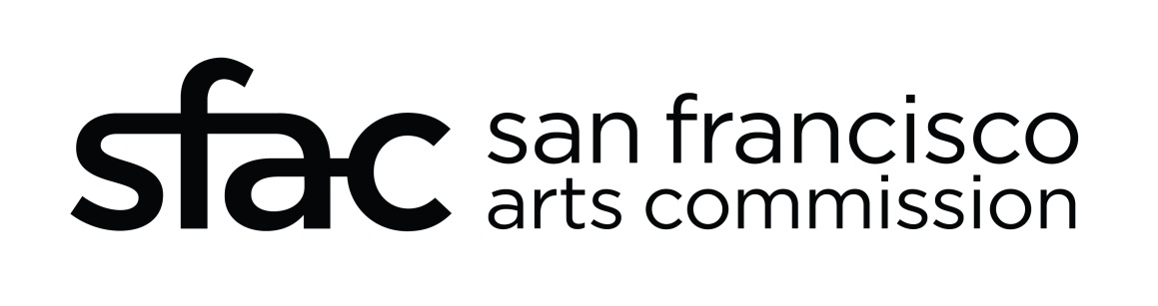
TITLE: San Francisco International Airport, Terminal 1 Redevelopment
Date: May 5, 2016
PROJECT OUTLINE: The project is a replacement terminal and concourse facility for San Francisco International Airport Terminal 1 including Boarding Area B and C. Terminal 1 and Boarding Area B were originally finished in 1961. The remodel of T1 BAB and Center Section will be included in the first phase of the project, to be completed in 2020. The entire T1 facilities have become outdated both in airport operations and passenger experience as set forth in SFO’s cultural design guidelines, the Revenue Enhancement and Customer Hospitality principles (the REACH document).
PROJECT GOALS
San Francisco International Airport’s public art program, provided by the San Francisco Arts Commission, offers a permanent collection of paintings, sculptures and site specific artworks that reflect the Bay Area’s vibrant and diverse culture. The collection comprises close to 100 pieces in a diversity of styles and media by artists of local, national and international acclaim. Our goal for the redevelopment of Terminal 1 is to commission dynamic contemporary art that offers the traveler and residents a powerful and continuous experience with art within the context of the airport environment. This will include the selection of artists to create large scale site specific artworks and installations, architectural integrated pieces, and the purchase of both 2 dimensional and discrete artwork as we continue to grow our outstanding civic collection.
DESIGN GOALS
Terminal 1, as with the Airport’s previous capital improvements, will be designed “inside-out” to improve the passengers experience and will feature a Bay Area airport journey.
The guiding principles for the design include the following:
- Revive, foster and celebrate a modern romance of travel
- Provide unexpected opportunities for airport guest. Fun. Discovery. Delight
- Ensure that all guests experience the Ease of Travel at the airport and beyond
- Communicate and deliver an authentic Bay Area experience
- Encourage access and opportunity for improving Health and Wellness for our guests and employees
Some key experiential words include:
- Quiet
- Craft
- Curated
- Community

ARTWORK OPPORTUNITIES:
- Pre-security lobby
- Post-security recompose
- Meet n’ Greet
- Market Place Intersection
- Mid-Pier artwork
- Slightline artwork at end of Pier
- Sterile corridor - apex
- Sterile Corridor - glass treatment
- Arrivals - suspended stair piece
- Arrivals - Welcome to the Living Room
- Arrivals – columns
- Curbside lighting artwork (70’)
Reinstallment of current artworks in the collection, such as the Tony Berlant which was recently deinstalled, and smaller 2D pieces in gate rooms.

BUDGET:
The budget for the T1 BAB and the T1 Center is $11.3 million. A preliminary budget outlining in the various projects has been established.
Art Opportunity | Amount
Admin | $ 2,846,994.00
Conservation | $ 565,000.00
other project costs | $ 178,006.00
Pre-security Lobby | $ 500,000.00
Post-Security Recompose | $ 1,000,000.00
Meet n' Greet | $ 400,000.00
Market Place Intersection | $ 500,000.00
2D artworks for gate rooms | $ 500,000.00
Mid-Pier art moment | $ 500,000.00
Sightline wow moment | $ 500,000.00
Sterile corridor (apex) | $ 300,000.00
Sterile corridor (glass treatment) | $ 250,000.00
Arrivals (suspended) | $ 300,000.00
Arrivals (Welcome to SF) | $ 200,000.00
Baggage Claim columns | $ 300,000.00
Curbside lighting artwork | $ 700,000.00
Relocate Burlant | $ 100,000.00
contingency | $ 1,747,978.00
TOTAL | $ 11,387,978.00

The immediate priorities include the following projects: Post-security recompose; Market place intersection; Mid-pier artwork; Sightline artwork at end of pier; Arrivals – suspended stair piece; Curbside Lighting artwork. These projects will look to keep the following timeframe.
SCHEDULE:
Issue RFQ July 2016
Selection Panel 1st meeting September, 2016
Selection Panel 2nd meeting late-October, 2016
Approval of selected artists by VAC October 19, 2016
Approval of selected artists by Full Commission November 7, 2016
Artists under contract December 2016

FURTHER INFORMATION
Contact Justine Topfer, Public Art Project Manager at (415)252-2228 or by email at Justine.topfer@sfgov.org.

