Mayor’s Task Force on Anti-Human Trafficking
Second Year Highlights: 2014

The Mayor’s Task Force on Anti-Human Trafficking continued to make strong strides during its second year of meeting, in 2014. A chart of the attendees follows. Highlights of the second year include:

- New Specialized Committees
The Task Force added two new committees, bring the active committees to four: (1) Child Sex Trafficking; (2) Illicit Massage Parlor; (3) Sex Worker & Trafficking; and (4) Super Bowl and Trafficking.

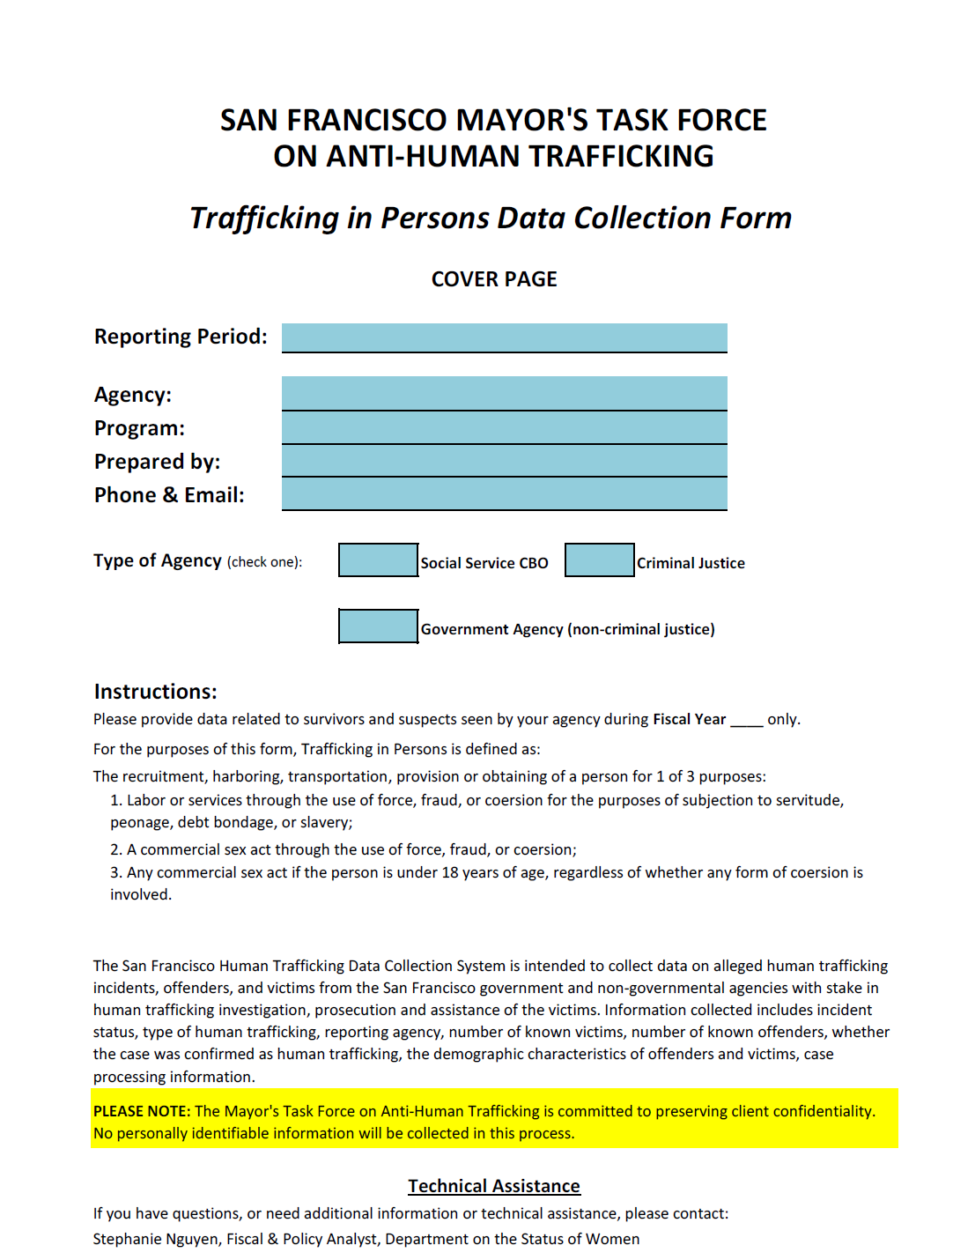
- Data Collection
The Task Force approved developing a data collection tool, and agreed to collect data for the last six months of 2014. Twelve government departments and eight non-profit agencies will be providing data.

- Identification of Crucial Needed After Hours Response to Commercially Sexually Exploited Children and Youth
The Child Sex Trafficking Committee identified a crucial gap in existing services which must be filled: the need for an after-hours emergency response to commercially, sexually exploited children and drafted a proposal to fund this need. Funding has not yet been secured for this service, and the Task Force continues to advocate for funding.

- SB 1193 Outreach Efforts
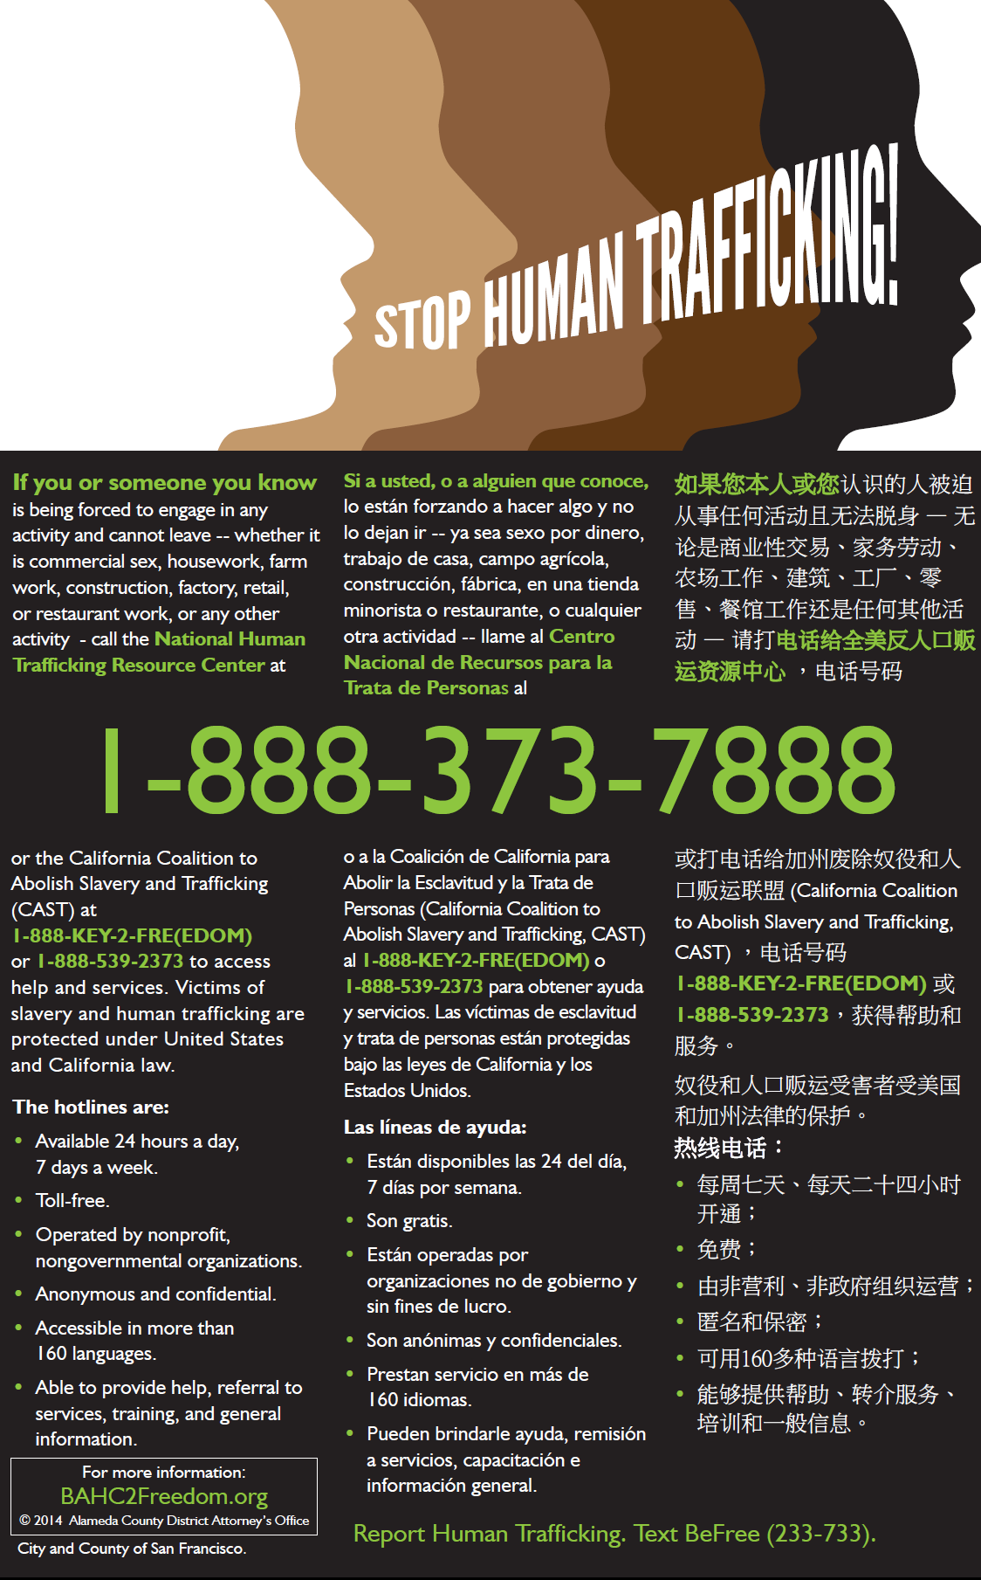
San Francisco collaborated with Alameda and San Mateo counties to design an anti-human trafficking notice containing all 3 required languages. On March 5, 2014, posters were mailed to 687 businesses affected by SB 1193, which requires certain California establishments to post anti-trafficking notices. The letters were accompanied by a letter signed by the Mayor and Police Chief, and a fact sheet. On April 5, 2014, San Francisco participated in a city wide check of bars, hospitals, and adult establishments. Thirty-three volunteers fanned out to 13 neighborhoods and visited 203 San Francisco businesses for the presence and appropriate placement of the poster. The Department of Public Health has also agreed to start monitoring for the presence of the poster when they inspect bars and massage establishments.

- Strengthening of Enforcement of Illicit Activities at Massage Parlors
The Department of Public Health assembled a compelling analysis of illegal activities at massage establishments in San Francisco, and was influential in shaping state legislation which passed in 2014 and brought back local control of massage establishments. The Illicit Massage Parlor Committee identified the need for bilingual health outreach workers to connect with women who might be trafficked at massage establishments, resulting in a budget request to the City to fund these positions.

- Policy and Protocol Development
The Human Services Agency agreed to opt into the state Department of Social Services’ program for Commercially Sexually Exploited Children. Building on relationships established through the Task Force, Family and Children’s Services will be creating an interagency protocol for responding to sexually trafficked youth.

The Sex Worker and Trafficking committee identified the need for policies at the Police Department and District Attorney’s office that would create an environment where sex workers who were victims or witnesses to violent crimes (like rape or trafficking) could feel safe reporting those crimes without fear of being arrested. Significant progress on the District Attorney policy took place in 2014, and the policy should be complete in 2015. The Police Department has also agreed on the need for a parallel policy.


- Super Bowl Planning
The Task Force forged new collaborations with Super Bowl 50 Host Committee and the regional efforts coordinated by the South Bay Coalition to End Human Trafficking. Human trafficking training for hospitality industry staff and discussion of supply chain audits were begun.

- Expanded Funding
The Department on the Status of Women approved funding for several new programs addressing human trafficking. Beginning in FY 15-16 pending final budget approval, Not for Sale will receive funding for its vocational program for sexually trafficked young adults; Safe House will receive funding for case work for its clients; and St. James Infirmary will receive funding for a “bad date” data system to expand a program that facilitates sex workers giving and getting information about dangerous predators.

- Training
- The San Francisco Unified School District trained all wellness center staff in child sex trafficking.
- The Department of Public Health trained 88 Environmental Health inspectors (who inspect restaurants and massage establishments) in spotting signs of human trafficking.

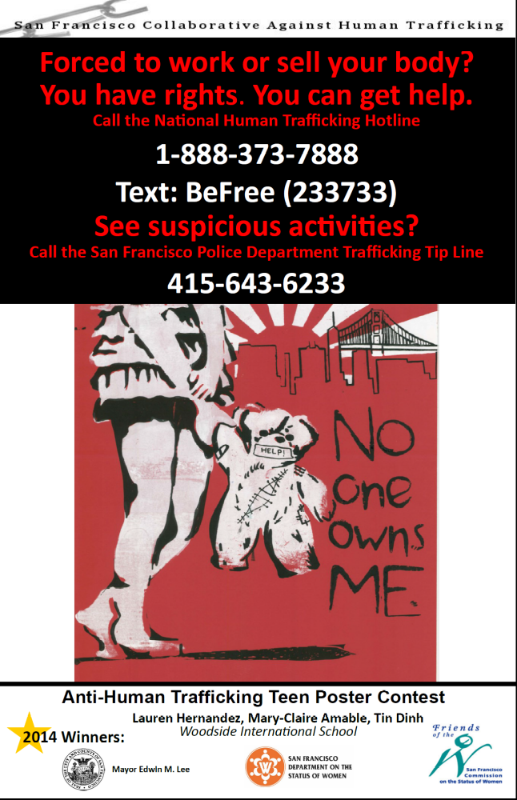
San Francisco Collaborative Against Human Trafficking 2014 Poster Contest Winner

2014 Participants in the Mayor’s Task Force on Anti-Human Trafficking
CITY DEPARTMENTS | STAFF
Board of Supervisors | Katy Tang, Dyanna Quizon, Carol Mo
CASARC | Dr. Tonya Chaffee
City Attorney’s Office | Elizabeth Pederson, Melissa Millsaps
Department of Children, Youth and Families | Glenn Eagleson, Mia Satya
District Attorney’s Office | Tara Anderson, Julius De Guia
Human Rights Commission | Nadia Babella
Human Services Agency | Johanna Gendelman, Barrett Johnson, John Tsutakawa
Juvenile Probation | Ana Villagran
Labor Standards Enforcement | Donna Mandel
Mayor’s Office | Paul Henderson, Diana Oliva-Aroche
Police | Capt. Teresa Gracie, Lt. Trenia Wearing, Sgt. Inspector Antonio Flores, Lt. Michael Dudoroff, Capt. Joseph McFadden
Public Defender | Rebecca Marcus, Simin Samji
Public Health | Edward Walsh, Alison Lustbader, Cindy Comerford, Cristy Dieterich
Status of Women | Dr. Emily Murase, Minouche Kandel, Stephanie Nguyen, Grace Fisher, Kristin Snell, Eva Morgenstein, Celia Flinn
Unified School District | Maya Webb, Carley Amigone
US Attorney’s Office | Annemarie Conroy
Victim Witness | Delia Montiel, Maria Bee
COMMUNITY AGENCIES | STAFF
APILO | Cindy Liou, Hyun-Mi Kim
Asian Women’s Shelter | Hediana Utarti, Elizabeth Kirton
Bayswan | Carol Leigh
California Massage Therapy Council | Beverly May
Community United Against Violence | Carolina Morales
ECPAT | Brenda Hepler
Family Builders | Jill Jacobs
Freedom House SF | Frances Byrne
Huckleberry Youth Programs | Mollie Brown, Patrick Buckalew
Larkin Street Youth Services | Irene Casanova
Legal Services for Children | Carolyn Reyes
LYRIC | Denny David
Nalls Foundation | Kelly Gillian
Northern Coalition Against Human Trafficking | Sister Marie Gaillac
Not for Sale | Venus Rodriguez
RTI International | Alexandra Lutnick
SAGE | Ellyn Bell, Paniz Bagheri
San Francisco Child Abuse Prevention Center | Kathy Baxter, Katie Albright
San Francisco Collaborative Against Human Trafficking | Nancy Goldberg, Antonia Lavine
SFWAR | Zully Batres
Sojourner Truth Foster Family Service Agency | Carletta Jackson-Lane
St. James Infirmary | Stephanie Ashley, Dee Michel, Cyd Nova, Pratima Gupta
US Prostitutes Collective | Rachel West

