Justifications for Requesting OCA to
Waive or Modify Standard Solicitation Procedures
Regulation 21.5(b): No Substitute for Product/Service and Only One Source (No Bid Required)
1. What is the purpose of this product or service?
2. Why this is the only product or service that will meet the City's needs?
3. If applicable, how long have the goods or services been used by your department?
4. What steps were taken to verify that this is the only vendor or contractor that can provide the services or products? (Attach supporting documentation)
5. What efforts were made to obtain the best possible price?
6. If there are 12B compliance issues, have you requested a waiver from CMD?

Regulation 21.5(b): No Substitute for Product/Service but More than One Source (Bid Required)
1. What is the purpose of this product or service?
2. Why are the design/performance features of this product or service essential to your department?
3. Have you contacted other suppliers to evaluate items/services with similar features and capabilities? If no, explain why not. If yes, list the suppliers and explain why their goods or services do not meet the department's needs.

Regulation 21.5(c): Perishable Foods
1. Please explain why the nature of perishable foods makes it impossible or highly impractical to obtain competitive pricing.

Regulation 21.5(d): Proprietary Articles and Only One Source (No Bid Required)
Choose from the following and answer the questions that follow:
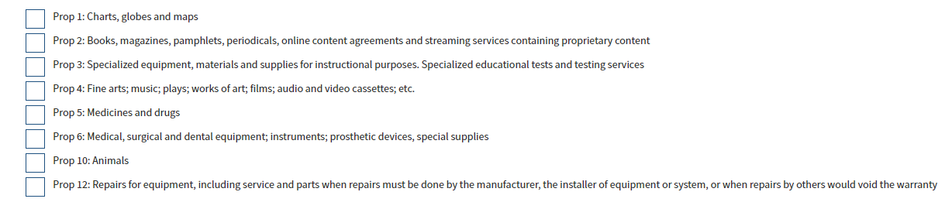
1. What is the purpose of this product or service?
2. Why this is the only product or service that will meet the City's needs?
3. Is the product or services proprietary in nature such that it is available from only one source? If yes, please provide a letter from the supplier supporting this assertion.

Regulation 21.5(d): Proprietary Articles but More than One Source (Bid Required)
Choose from the following and answer the questions that follow:
1. What is the purpose of this product or service?
2. Why this is the only product or service that will meet the City's needs?

Regulation 21.5(e): Pilot Project with a Term Not to Exceed Two Years
1. Specify the problem to be solved and the reason why a competitive process cannot currently be used.
2. Who are the pilot project participants (vendors) and how were they selected?
3. What is the anticipated amount ($) and duration of the pilot project?
4. How will the pilot project allow the department to develop evaluation criteria for a competitive solicitation in the future?
5. Specify how competition, fairness, and compliance with other OCA requirements for bidding will be achieved upon completion of the pilot.

Regulation 21.5(g): Federal Funds (If selected, no additional questions or information required)

Regulation 21.6(b): Reciprocal Agreements with Other Public and Non Profit Agencies
1. Provide an overview of the competitive process or sole source process utilized by the cooperative agency, other government entity, in procuring the contract. You must upload the full competitive solicitation of the other agency to this request.
2. Why is the pricing offered under the contract is better than what the City can otherwise obtain or how do the administrative benefits of using the contract outweigh any likely cost difference?
3. Will the piggybacking materially hinder the City's ability to meet its LBE participation goals?
4. What are the fees, if any, that must be paid by the City to the entity that established the contract in question?
5. Has the department compared the contracts available for the required product or service, conducted market research, and evaluated whether the use of another agency's contract is in the best interest of the City?
6. Has the department reviewed the contract for conformance with applicable laws and best practices?
7. Has the department analyzed the product or service specifications, price, terms and conditions and other factors such as: cost to utilize the contract, shipping, minimum spending requirements, and availability of contract documentation, to ensure that the contract produces best value?
8. Are the goods or services being sought substantially similar to those discussed in the original solicitation? If so, please explain.
9. Has the department contacted the lead agency to verify contract application and eligibility?

Regulation 21.6(c): Solicitations for Multiple Departments
1. Did you upload the full competitive solicitation of the other agency to this request.
2. Does the competitive Solicitation by the other City department state that it may be used by other City departments?
3. Are the goods or services being sought substantially similar to those discussed in the original solicitation? If so, please explain.

Regulation 21.30: Proprietary Software Licenses and Support and Proprietary Equipment Maintenance
Choose from the following and answer the questions that follow:
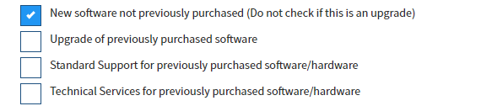
1.Did you upload a letter from the Supplier confirming that this software or equipment maintenance (whichever is applicable) is proprietary in nature and can only be purchased from the proposed Supplier?
2. If you selected "New software" or "Upgrade of previously purchased software", answer each question below:
a. What is the purpose of this software?
b. Why this is the only software that will meet the City's needs?
c. What efforts were made to obtain the best possible price?
Choose from the following and answer the questions that follow:
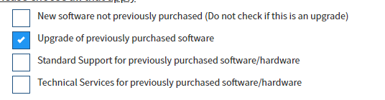
1. Did you upload a letter from the Supplier confirming that this software or equipment maintenance (whichever is applicable) is proprietary in nature and can only be purchased from the proposed Supplier?
2. If you selected "New software" or "Upgrade of previously purchased software", answer each question below:
a. What is the purpose of this software?
b. Why this is the only software that will meet the City's needs?
c. What efforts were made to obtain the best possible price?
Choose from the following and answer the questions that follow:
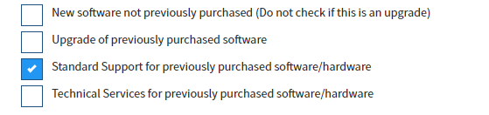
1. Did you upload a letter from the Supplier confirming that this software or equipment maintenance (whichever is applicable) is proprietary in nature and can only be purchased from the proposed Supplier?
Choose from the following and answer the questions that follow:
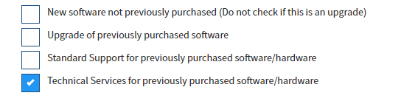
1. Did you upload a letter from the Supplier confirming that this software or equipment maintenance (whichever is applicable) is proprietary in nature and can only be purchased from the proposed Supplier?

