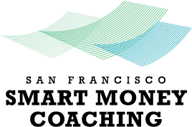

Smart Money Coaching
For Older Adults and Adults with Disabilities

Smart Money Coaching is a free, confidential financial coaching program that
can help you with issues around debt, savings, banking and credit.

Personal: We start where you are in your personal and financial life.

Customizable: We address your specific financial needs and challenges.

Actionable: We will provide clear steps and actions, so you can improve
your financial life.

To get started, contact:
Travis Spain
phone: 415.865.5534
e-mail: traviss@sfcenter.org

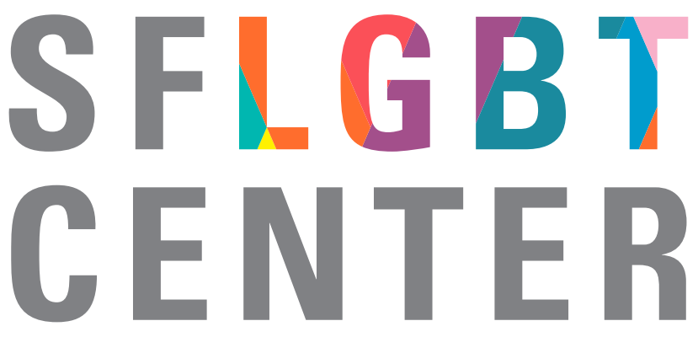
1800 Market Street
San Francisco, CA 94102
415.865.5661
sfcenter.org

