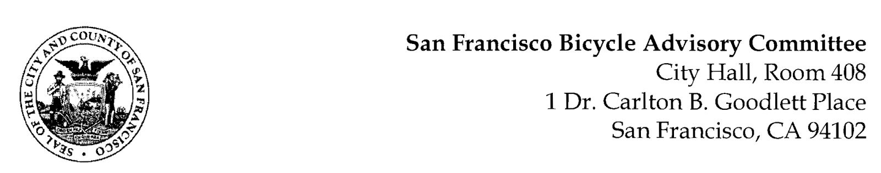

MEETING AGENDA
Monday, February 24, 2020 at 6:30 P.M.
Members: District 1 – Kristin Tieche, District 2 – Charles Deffarges, District 3 - Marc Brandt, District 4 – Anne Brask, District 5 -Melyssa Mendoza (Secretary), District 6 – Mary Kay Chin, District 7 - Bert Hill (Chair), District 8 - Diane Serafini, District 9 – Kisai Henriquez, District 10 - Paul Wells (Vice Chair), District 11 – Jeffrey Taliaferro

ORDER OF BUSINESS
- Roll Call – Determination of Quorum

- Announcements & Acknowledgments

- Approve Minutes – Monday, January 27, 2020 Meeting

- Public Comment (Discussion Item)
The public may address the Committee on any matter within the jurisdiction of the Committee. This should not relate to any item on this agenda since the Committee will take public comment after it discusses and/or before voting on each agenda item. The Committee requests that each person limit him/herself to three minutes

- Committee Member Reports (Information)
  - Chairman's Report - Review of re-appointments
  - Committee Member Reports

- Governmental/Organizational/Committee Reports (Discussion Item)
  - SFPD Report – A/Capt. Luke Martin
  - DPW Report – Jeremy Spitz
  - MTA Bicycle Program Report - Maia Moran & Jenn Chan
  - BART Bicycle Advisory Task Force Report - Rick Goldman (Excused)
  - Vision Zero Coalition Report – Bert Hill (Paul Wells, Acting)
  - Communications Committee – Charles Deffarges (Excused)
  - Ghost Bike Memorial Committee – Charles Deffarges (Excused)

7. Prop D Traffic Congestion Mitigation Tax (Discussion) Anna Laforte and Mike Pickford, SFCTA– In November 2019, SF voters passed Prop D to tax commercial rideshare trips (i.e. Uber, Lyft, others) in the City to fund safer streets and improved transit. Half of the revenue will come to the SFCTA for street safety improvements, and we are seeking feedback from stakeholders on their priorities for the SFCTA portion of funding.
8. Ghost tracks & resultant bicycle and other two wheel accidents (Discussion) Paul Wells – The remnant of Southern Pacific and the Belt Railway delivering freight cars on rails in much of the Waterfront, SOMA, and the South East sector.

9. Adjournment

DISABILITY ACCESS:
Room 408 of City Hall is wheelchair accessible. The closest accessible BART Station is Civic Center, three blocks from City Hall. For more information about MUNI accessible services, call 923-6142. There is accessible parking in the vicinity of City Hall at Civic Center Plaza.
Large print copies of the agenda, sign language interpreters, or assistive listening systems can be made available by contacting the DPT staff liaison, Lorraine R. Fuqua, at 415-554-9808.The deadline for these services shall be 4:00 p.m. of the last business day of the preceding week.
In order to assist the City’s eforts to accommodate persons with severe allergies, environmental illnesses, multiple chemical sensitivity, or related disabilities, attendees at public meetings are reminded that other attendees may be sensitive to various chemical based products. Please help the City accommodate these individuals . Individuals with chemical sensitivity or related disabilities should call our accessibility hotline at (415) 554- 6789.
KNOW YOUR RIGHTS UNDER THE SUNSHINE ORDINANCE
Know your rights under the Sunshine Ordinance (Chapter 67 of the San Francisco Administrative Code) Government’s duty is to serve the public, reaching its decisions in full view of the public. Commissions, boards, councils, and other agencies of the City and County exist to conduct the people’s business. This ordinance assures that deliberations are conducted before the people and that City operations are open to the people’s review.
For more information on your rights under the Sunshine Ordinance or to report a violation of the ordinance, contact the Sunshine Ordinance Task Force, by mail to Chris Rustom, Administrator, Sunshine Ordinance Task Force, 1 Dr. Carlton B. Goodlett Place, Room 244 San Francisco, CA 94102-4683; by telephone 415-554-7724, by Fax 415-554-7854, or by email: sotf@sfgov.org

LOBBYIST ORDINANCE
Individuals and entities that influence or attempt to influence local legislative or administrative action may be required by the San Francisco Lobbyist Ordinance [SF Campaign & Governmental Conduct Code §2.100] to register and report lobbying activity. For more information about the Lobbyist Ordinance, please contact the San Francisco Ethics Commission at 25 Van Ness Avenue, Suite 220 San Francisco, CA 94102, Phone: (415) 252-3100/Fax: (415) 252-3112, Email:ethics.commission@sfgov.org.

