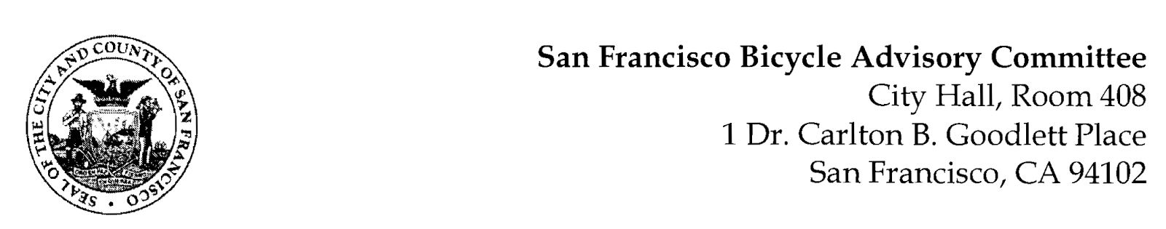

https://www.facebook.com/events/201778428315028
MEETING AGENDA
Monday, January 25, 2021
Members: District 1 – Ms. Kristin Tieche- (Vice Chair), District 2 – Ms. Sarah Boudreau , District 3 – Mr. Marc Brandt, District 4 – Ms. Anne Brask, District 5 -Ms. Melyssa Mendoza (Secretary), District 6 – Ms. Mary Kay Chin, District 7 – Mr. Bert Hill (Chair), District 8 – Ms. Diane Serafini, District 9 – Mx. Kisai Henriquez, District 10 – Mr. Paul Wells, District 11 – Mr. Jeffrey Taliaferro

ORDER OF BUSINESS
- Roll Call – Determination of Quorum

- Announcements & Acknowledgments

- Approve Minutes – Monday, November 30, 2020

- Public Comment (Discussion Item)
The public may address the Committee on any matter within the jurisdiction of the Committee. This should not relate to any item on this agenda since the Committee will take public comment after it discusses and/or before voting on each agenda item. The Committee requests that each person limit him/herself to three minutes

- Committee Member Reports (Information)
  - Chairman's Report – Reminder of BAC Applications
- Committee Member Reports
- Governmental/Organizational/Committee Reports (Discussion Item)
  - SFPD Report – Lt. Conley, Richmond District
  - DPW Report – Jeremy Spitz
  - MTA Bicycle Program Report - Maia Moran
  - BART Bicycle Advisory Task Force Report - Rick Goldman
  - Vision Zero Coalition Report – Bert Hill (Presentation)

- Bay Wheel Update & Plans for BORP (Discussion) Neal Patel- A discussion on the progress of Bay Wheels in San Francisco, as well as a look at BORP (Bay Area Opportunities Recreation Program for people with special challenges, especially blindness.
- Better Market Street (Resolution) Sarah Bouderau- Following SFMTA's presentation regarding Better Market Street on October 26 (on the planned improvements and current status on San Francisco’s Main Street), several community groups have expressed disappointment in the proposed changes to Better Market Street and have provided opportunities to provide feedback on the changes (https://actionnetwork.org/petitions/save-the-protected-bike-lanes-on-market-street, as well as the San Francisco Bicycle Coalition and Walk SF, among others).

- Adjournment

