Caltrain Electric Train Configuration
6-car electric train, 7th car to be added is E (powered)
B (cab) C (bathroom) D (unpowered) E (powered) F (unpowered) A (cab)

Caltrain’s Approved Layout: Two Bike Cars
D/F car (unpowered) -- two per trainset
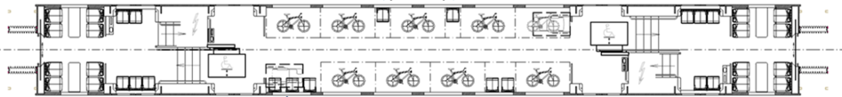

Problems:
- Increases risk of bike theft with only seven folding seats within view of 36 bikes
- Causes congestion in bike cars with people standing to guard their bikes during both peak and off-peak
- Increases dwell time by forcing people with bicycles to board at only two cars
- Emergency exit windows blocked by stacked bikes
- Only 72 bike spaces per train, fewer than today’s diesel trains which have 77 bike spaces per train

Recommended Compromise Layout: Four Bike Cars
D/F car (unpowered) -- two per trainset

E car (powered) -- two per trainset

Features:
- Each bike car has at least half as many fixed seats as bikes (same as today) to deter bike theft
- Minimal congestion in bike-car aisles to keep trains on time
- Reduces dwell time by enabling people with bicycles to board at four cars
- Emergency exit windows accessible, not blocked by stacked bikes
- 80 bike spaces per train, a nominal increase over today’s diesel trains

