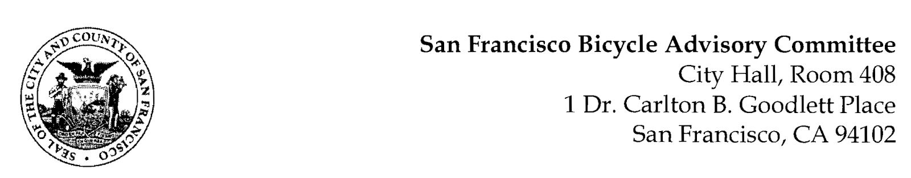

https://www.facebook.com/events/208979257630917
MEETING AGENDA
Monday, February 22, 2021
Members: District 1 – Ms. Kristin Tieche- (Vice Chair), District 2 – Ms. Sarah Boudreau , District 3 – Mr. Marc Brandt, District 4 – Open, District 5 -Ms. Melyssa Mendoza (Secretary), District 6 – Ms. Mary Kay Chin, District 7 – Mr. Bert Hill (Chair), District 8 – Ms. Diane Serafini, District 9 – Mx. Kisai Henriquez, District 10 – Mr. Paul Wells, District 11 – Mr. Jeffrey Taliaferro

ORDER OF BUSINESS
- Roll Call – Determination of Quorum

- Announcements & Acknowledgments

- Approve Minutes – Monday, January 25, 2021

- Public Comment (Discussion Item)
The public may address the Committee on any matter within the jurisdiction of the Committee. This should not relate to any item on this agenda since the Committee will take public comment after it discusses and/or before voting on each agenda item. The Committee requests that each person limit him/herself to three minutes

- Committee Member Reports (Information)
  - Chairman's Report – Reminder of BAC Applications – Melyssa, Marc, Kisai, Melyssa, & Paul(?) Approved
- Committee Member Reports
- Governmental/Organizational/Committee Reports (Discussion Item)
  - SFPD Report – Lt. Conley, Richmond District (Absent)
  - DPW Report – Jeremy Spitz
  - MTA Bicycle Program Report - Maia Moran
  - BART Bicycle Advisory Task Force Report - Rick Goldman
  - Vision Zero Coalition Report – Bert Hill

- Vision Zero Action Strategy Presentation (Discussion) Mike Jacobson, Planner, MTA Livable Streets - Review of the overall purpose and goals of the Action Strategy Update, and how they might match the priorities and ideas with the BAC. It will also help to inform the priorities and strategies for safer streets
Adjournment

