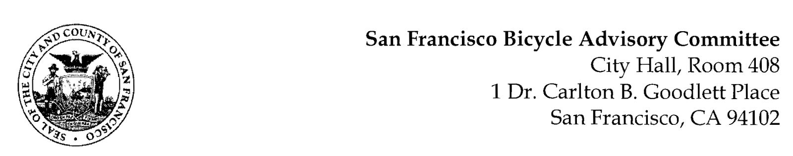

https://www.facebook.com/events/208979257630917
MEETING AGENDA
Monday, March 22, 2021
Members: District 1 – Ms. Kristin Tieche- (Vice Chair), District 2 – Ms. Sarah Boudreau , District 3 – Mr. Marc Brandt, District 4 – Open, District 5 -Ms. Melyssa Mendoza (Secretary), District 6 – Ms. Mary Kay Chin, District 7 – Mr. Bert Hill (Chair), District 8 – Ms. Diane Serafini, District 9 – Mx. Kisai Henriquez, District 10 – Mr. Paul Wells, District 11 – Mr. Jeffrey Taliaferro

ORDER OF BUSINESS
- Roll Call – Determination of Quorum

- Announcements & Acknowledgments

- Approve Minutes – Monday, February 22, 2021

- Public Comment (Discussion Item)
The public may address the Committee on any matter within the jurisdiction of the Committee. This should not relate to any item on this agenda since the Committee will take public comment after it discusses and/or before voting on each agenda item. The Committee requests that each person limit him/herself to three minutes

- Committee Member Reports (Information)
  - Chairman's Report – Livable City, Portola
- Committee Member Reports
- Governmental/Organizational/Committee Reports (Discussion Item)
  - SFPD Report – Open
  - DPW Report – Jeremy Spitz
  - MTA Bicycle Program Report - Maia Moran
  - BART Bicycle Advisory Task Force Report - Rick Goldman
  - Vision Zero Coalition Report – Bert Hill
8. Downtown Congestion Pricing (Update from November Presentation) Brittany Chan - Without intervention we expect a rebounding economy to bring the return of congestion and its negative impacts to the downtown part of the City. The pandemic is spurring the Transportation Authority to think about the kind of future we want. The work we do now can help us plan and prepare for the recovery with policies that discourage single occupancy vehicles from the dense downtown neighborhoods, while achieving goals around street safety, clean air, and equity.
Adjournment

