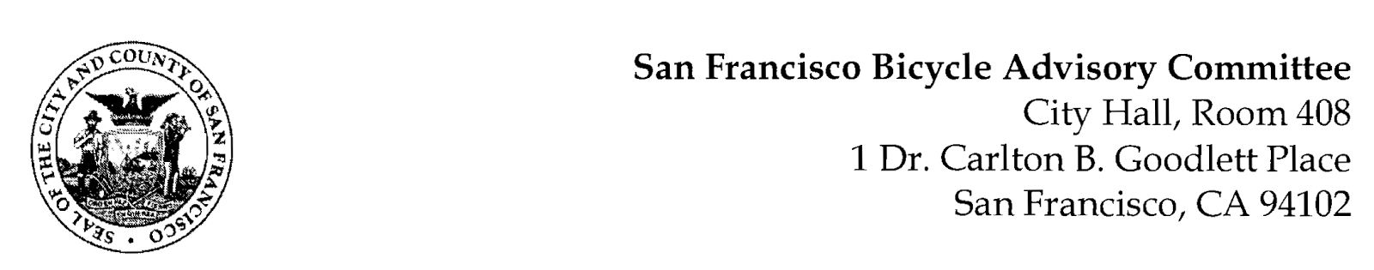
https://www.facebook.com/events/151310286929607/
MEETING AGENDA
Monday, April 26, 2021
Members: District 1 – Ms. Kristin Tieche- (Vice Chair), District 2 – Ms. Sarah Boudreau , District 3 – Mr. Marc Brandt, District 4 – Open, District 5 -Ms. Melyssa Mendoza (Secretary), District 6 – Ms. Mary Kay Chin, District 7 – Mr. Bert Hill (Chair), District 8 – Ms. Diane Serafini, District 9 – Mx. Kisai Henriquez, District 10 – Mr. Paul Wells, District 11 – Mr. Jeffrey Taliaferro

ORDER OF BUSINESS
- Roll Call – Determination of Quorum

- Announcements & Acknowledgments

- Approve Minutes – Monday, March 22, 2021

- Public Comment (Discussion Item)
The public may address the Committee on any matter within the jurisdiction of the Committee. This should not relate to any item on this agenda since the Committee will take public comment after it discusses and/or before voting on each agenda item. The Committee requests that each person limit him/herself to three minutes

- Committee Member Reports (Information)
  - Chairman's Report
- Committee Member Reports
- Governmental/Organizational/Committee Reports (Discussion Item)
  - MTA Bicycle Program Report - Maia Moran
  - BART Bicycle Advisory Task Force Report - Rick Goldman
  - SF Bicycle Coalition – Kristen Leckie
  - Bay Wheels – Neal Patel
  - SF Park & Rec – Brian Stokle
8. Safe JFK for All – The State & Fate of Car-Free JFK (Discussion) Kristin Tieche/Sarah Boudreau - A silver lining for many during the COVID-19 pandemic has been rapid progress in creating street spaces for people. Now that San Francisco is beginning to reopen, the conversation begins about whether we will return to "normal" or build a sustainable, equitable, safe future. JFK Drive in Golden Gate Park is a focal point in this conversation. Let's discuss Car-Free JFK, bicycle safety, supporters and opponents, positives and limitations, next steps, and whether the BAC should issue a resolution in support of keeping JFK car-free.

- JFK & Kezar Eastbound Intersection (Resolution) Marc Brandt – The connection for people on ‘micromobility devices’ (non-vehicular Active Transportation) have long been challenged when crossing Kezar Drive West of Stanyan Street with the intent of entering the Panhandle bike lanes. It has become increasingly dangerous recently with vehicle operators driving unsafely at the same time that more cyclists and other micromobility users are trying to cross Kezar on JFK drive without road treatments to improve safety. On March 6 cyclist was injured at this intersection, bringing attention to the need for changes.
- Folsom Streetscape Project Update (Discussion) Alan Uy, Project Mgr. or Thalia Leng – Providing a project update including the timeline. This is an informational presentation following an previous presentation.

Adjournment

