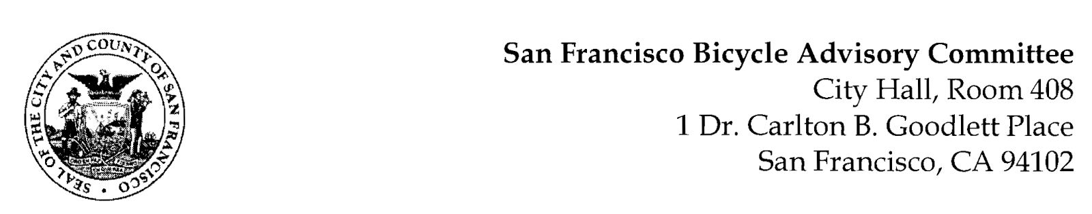
https://www.facebook.com/events/619552328962331/
MEETING AGENDA
Monday, July 26, 2021
Members: District 1 – Ms. Kristin Tieche- (Vice Chair), District 2 – Ms. Sarah Boudreau , District 3 – Mr. Marc Brandt, District 4 – Open, District 5 -Ms. Melyssa Mendoza (Secretary), District 6 – Ms. Mary Kay Chin, District 7 – Mr. Bert Hill (Chair), District 8 – Ms. Diane Serafini, District 9 – Mx. Kisai Henriquez, District 10 – Mr. Paul Wells, District 11 – Mr. Jeffrey Taliaferro

ORDER OF BUSINESS
- Roll Call – Determination of Quorum

- Announcements & Acknowledgments

- Approve Minutes – Monday, June 28, 2021

- Public Comment (Discussion Item)
The public may address the Committee on any matter within the jurisdiction of the Committee. This should not relate to any item on this agenda since the Committee will take public comment after it discusses and/or before voting on each agenda item. The Committee requests that each person limit him/herself to three minutes

- Committee Reports & Administrative Business (Information)
  - Chairman's Report
  - District Committee Member Reports

- Governmental/Organizational/Committee Reports (Discussion Item)
  - MTA Bicycle Program Report - Maia Moran
  - SFPD Traffic Division – Leut. Luke Martin
  - BART Bicycle Advisory Task Force Report – Rick Goldman No Report
  - Bay Wheels – Neal Patel
  - SF Park & Rec – (Brian Stokle) TBA
- Support of a Pilot of the Upper Great Highway Promenade with Nearby Vehicular Traffic Improvements (Resolution) – As we approach the end of the declared Pandemic Emergency, with temporary changes that promote Active Transportation and Pedestrianized roadways, the debate over the Great Highway in review with Rec & Park, the County Transportation Authority (CTA), and the Board of Supervisors remains not solved. Last month, the CTA presented five suggested concepts for review. Members of the BAC will propose a Resolution of Recommendation to be considered by the Board of Supervisors.
- Adjournment

