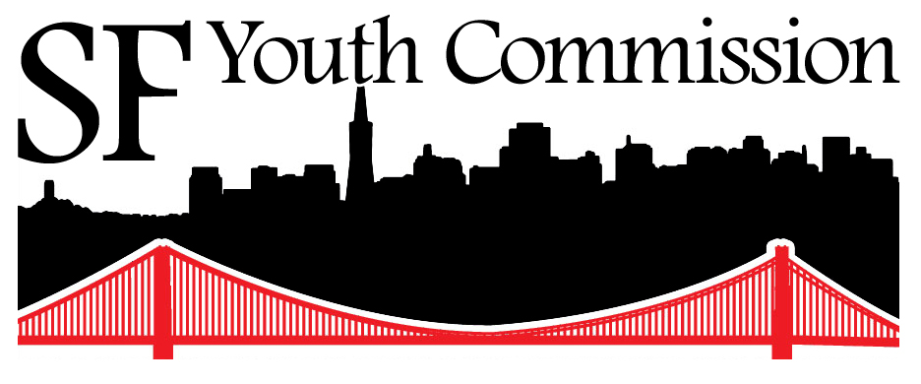

Do you have an opinion about how this City makes decisions that affect you and your friends?

Join the San Francisco Youth Commission!

Application for 2013-2014 Term

Due Friday, April 19, 2013 at 6:00pm.

San Francisco Youth Commission
City Hall, Room 345
1 Dr. Carlton B. Goodlett Pl
San Francisco, CA 94102
Phone: (415) 554-6446
Fax: (415) 554-6140
Email: youthcom@sfgov.org
www.sfgov.org/yc
Please refer questions to:
Phimy Truong, Adele Carpenter, or Allen Lu, Youth Commission Staff
Phone: (415) 554-6446
Email: youthcom@sfgov.org


Basic Information
Who We Are:
The Youth Commission is a group of 17 San Franciscans between the ages of 12 and 23. Each member of the Board
of Supervisors appoints one Youth Commissioner, and the Mayor appoints six more.

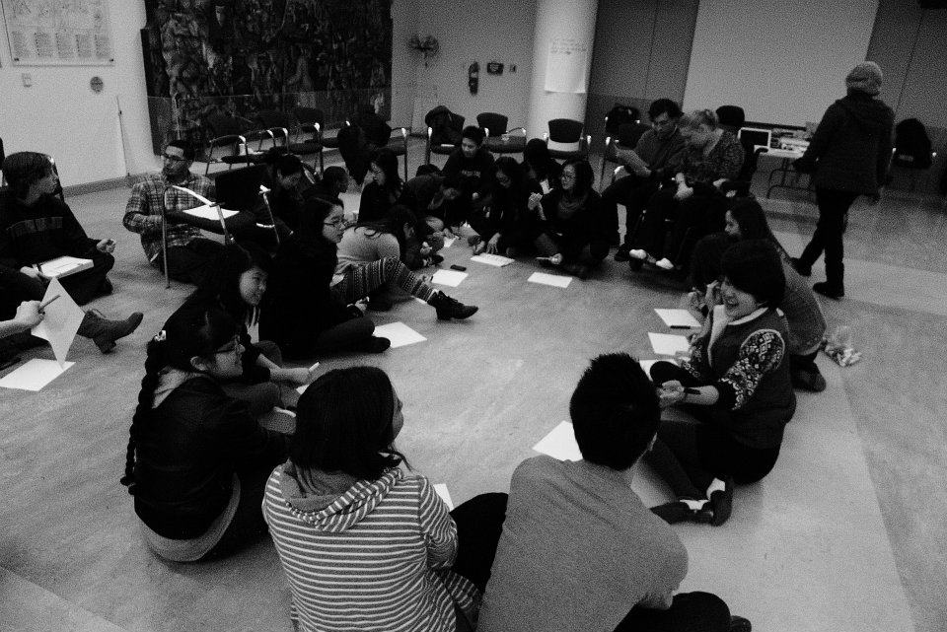
What We Do:
-Our job, which was created by the voters of San Francisco and makes us accountable to
the whole City, is to stand up for the needs of all young people in the policy and legislative
debates at City Hall.
-Whether it comes to MUNI, housing, education, juvenile justice or
health and wellness, we serve as authentic advisors on youth issues to the Board of
Supervisors and the Mayor. (See the next page for some examples of our recent work.)
-We read laws, talk to Supervisors and the Mayor Office, hold discussions with other young people in our communities, organize events and hearings, do research on policy
and write resolutions.

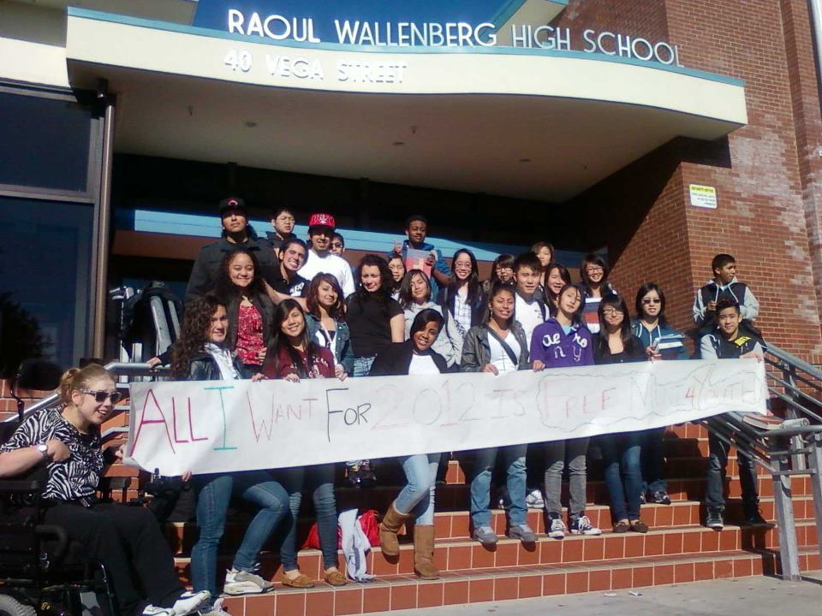
How We Do It:
-Youth Commissioners can influence government in a number of ways.
-For example, the Youth Commission must consider any proposed law that would affect young people and decide whether or not the proposed law would be good for young people. Youth Commissioners then have opportunity to convince lawmakers to pass or reject the proposed law.
-Also, Youth Commissioners can develop their own policies and laws relating to young people and try to convince the Mayor and the Board of Supervisors to pass them.

When:
-The Youth Commission is a very serious time commitment.
-The commission has a minimum time requirement of 15 hours per month, spread out over about 4 hours per week.
-There are full commission meetings that you are required to attend at least twice a month. There are also at least three other kinds of meetings you must attend at least once a month: small committee meetings, meetings with members of the Board of Supervisors and the Mayor’s Office, and meetings with young people outside of City Hall in various communities across the city.

Do I Need Previous Experience?
-No! Anybody can be a Youth Commissioner!
-The only requirements are that you live in San Francisco and be between the ages of 12 and 23 when you are appointed.
-And: be passionate about youth and community issues—about the decisions the City makes that affect you and your friends!

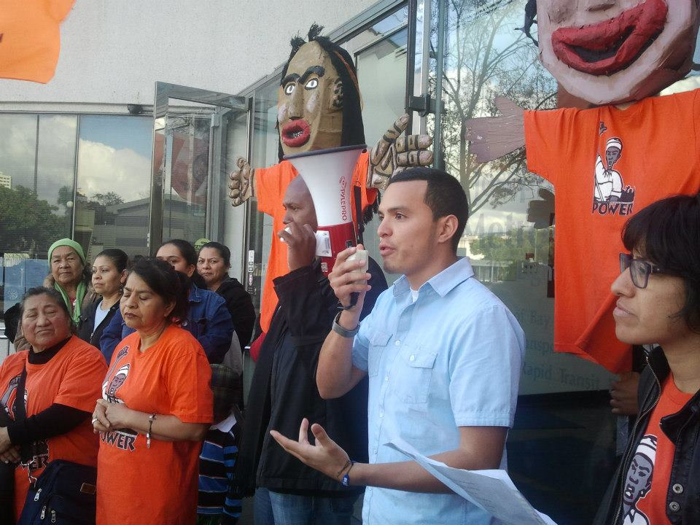
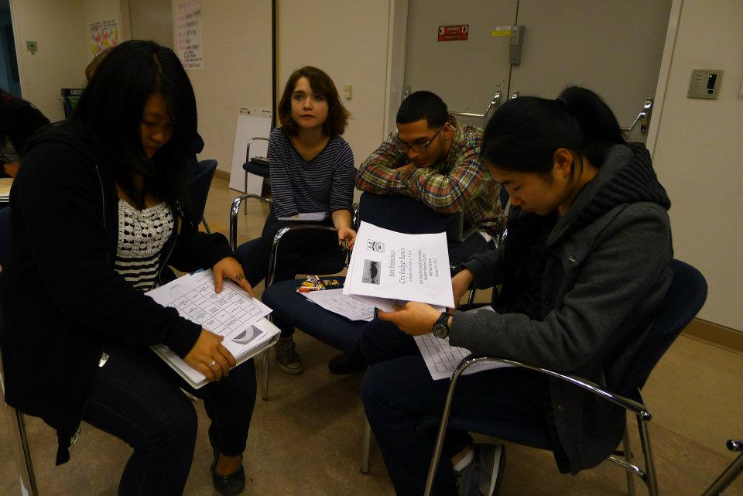
Do I Get Paid?
-No—the City Charter doesn’t allow Youth Commissioners to be paid.
-However, you can receive health care.

Recent Examples of the Youth Commission’s Work

LGBTQ Sensitivity in City Services

Concerned about the experiences of lesbian, gay, bi, trans, queer, and questioning youth accessing city services, youth commissioners made a motion calling on the Board of Supervisors to host a hearing on the implementation of LGBTQ sensitivity training for youth-serving staff in the city.

Three members of the Board of Supervisors agreed to host a hearing in Spring 2013. This hearing will be an opportunity to discuss learning objectives of the staff training and assess administrative barriers to LGBTQ’s youth’s access to city services.



Free MUNI Fast Passes for low- and moderate-income youth

In February 2010, MUNI planned to raise the price of the Youth Fast Pass to $30/month at the same time as San Francisco students were experiencing cut-backs to yellow school bus service.

After first working to get a limited number of discounted passes approved, the Youth Commission worked with community-based organizations to advocate for Free MUNI for San Francisco Youth. In 2012, MUNI’s Board of Directors approved a 16-month pilot that would provide 40,000 eligible youth free bus passes beginning in March 2013.

Over 20,000 low- and moderate-income San Francisco youth have signed up for this program so far!

We are working to ensure this program continues next year. Ask us about how to apply for a pass!




Working for the rights of youth in the juvenile justice system

Members of the Youth Commission’s youth justice committee have worked on several initiatives aimed at protecting the rights of justice-system involved youth. Youth commissioners have promoted a restorative and rehabilitative approach to juvenile justice by advocating for full access to the recreation yard at juvenile hall. They have advocated against the arming of juvenile probation officers with firearms and for police training on youth-police interactions to promote better understanding and the use of deescalation techniques.



How to Apply

The application process and timeline for the 2013-2014 term are as follows:

- Fill out the attached application (i.e., personal information, applicant agreement, and essay questions) and turn it in to the Youth Commission (by fax, email, regular mail or in person). The application is due Friday, April 19, 2013 at 6:00pm. Late applications will not be accepted.

- Come in for an interview with Youth Commission staff.
Exact dates and times will be announced after you turn in your application.

- The Board of Supervisors and the Mayor’s Office might ask you to come in and do their own interviews. You are welcome to contact the Mayor and the Board yourself! Just ask us how.

- The Youth Commission staff make recommendations to the Board of Supervisors and the Mayor’s Office of who to appoint to the commission. Ultimately, the members of the Board of Supervisors and the Mayor choose who to appoint to the Youth Commission. We hope the Mayor and the Board of Supervisors make their appointments by June 19, 2013.

The 2012-2013 Youth Commission term begins at the Beginning of the Year Retreat on August 23, 24 and 25 2013.

***IMPORTANT***

PLEASE NOTE:

The Youth Commission is a serious time commitment.

If appointed, in addition to the required 15 hours per month described on the “Basic Information” page above you are required:

- to attend a 3 day retreat August 23, 24 and 25, 2013—all 3 days;

- to attend all of a full, two-day “mid year” retreat Saturday and Sunday, January 11 and January 12, 2014

Personal Information

Name____________________________________________________________________________________________________________

Address_________________________________________________________________________________________________________

Zip Code________________________________________________________________________________________________________

Email___________________________________________________________________________________________________________

Cell Phone_____________________________________________________________________________________________________

Home Phone___________________________________________________________________________________________________

Birthday______________________________ Age___________________________________________________________________

Additional optional information:

Ethnicity/Nationality/Race______________________________________________________________________________________

Languages spoken________________________________________________________________________________________________

Sexual orientation________________________________________________________________________________________________

Gender identity ___________________________________________________________________________________________________

If you are or will be in school, what school will you attend in the fall of 2013?

Please list all other schools you have gone to:

______________________________________________________________________________
What communities do you feel connected to?
(Examples: Gay, Lesbian, Transgender, Disabled, Homeless, Teen Parent, Low-Income, Irish American) Remember: you are not limited to these choices. Feel free to add your own.

Applicant Agreement

Please initital next to the statement(s) you agree with.

I, _____________________________________________________,
(name)

Certify that:

_____________The information provided in this application is accurate and I have made every attempt to answer all questions truthfully and to the fullest extent possible.

_____________I have reviewed the application and the required dates for the 2013-2014 Youth Commission term and understand that the 15 hour a month requirement is mandatory.

_____________I understand that this year’s Beginning of the Year Oreintation Retreat will be held on Friday, Saturday and Sunday, August 24, 25 and 26, 2013, and that my attendance is required on all days. I also understand that there will be additional days of training, and on Saturday and Sunday, January 19 and 20, 2014—and that all of these days are required.

Print Name_______________________________________________

Signature_________________________________________________

Date_______________________________________________________

Essay Questions

- Why do you want to be a Youth Commissioner?

- What are some issues that affect you or your community? If you had a meeting with the Mayor or a member of the Board of Supervisors tomorrow, what would you talk about with them and advise them on?

- What are some of your past accomplishments that you are proud of?

- The Youth Commission requires a commitment of at least 15 hours a month. In order to truly make an impact, it is often necessary to go beyond that minimum commitment. What other commitments do you have during the school year and in what ways are you prepared to dedicate time to meet the Commission’s goals?

- Please provide a letter of recommendation—a few paragraphs are sufficient—from someone not in your family (for example, a teacher, counselor, probation officer, etc.) regarding your work. THIS IS OPTIONAL. If you can’t get or don’t want to submit a letter of recommendation, please explain why.

Submit application in person, by fax, regular mail, email or carrier pigeon to:

San Francisco Youth Commission
City Hall, room 345
1 Dr. Carlton B. Goodlett Pl.
San Francisco, CA 94102
Fax: (415) 554-6140
Phone: (415) 554-6446
Email: youthcom@sfgov.org

The application is due Friday, April 19, 2013 at 6:00pm. Late applications will not be accepted.

