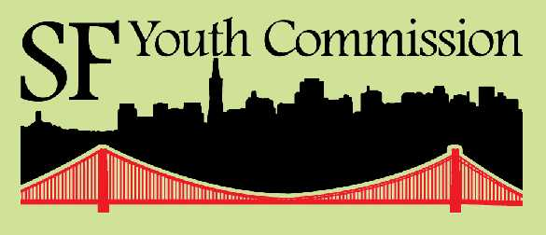
City Hall
1 Dr. Carlton B Goodlett Place, Rm. 345
San Francisco, CA 94102
415/554-6446 (phone)
415/554-6140 (fax)
www.sfgov.org/youth_commission

2012-2013 Youth Commission

Commissioner MIA SHACKELFORD

Chair
Appointed by Mayor Edwin M. Lee

Commissioner NICHOLAS PERSKY

Vice-Chair
Appointed by Mayor Edwin M. Lee

Commissioner Paul monge-rodriguez

Legislative Affairs Officer
Appointed by Mayor Edwin M. Lee

Commissioner Rachel Brodwin

legislative affairs Officer
Appointed by Supervisor Scott Wiener

Commissioner christine huynh

communications & Outreach officer
Appointed by Supervisor Jane Kim

Commissioner Sarah Armstrong
Appointed by Supervisor Norman Yee

Commissioner Angel Carrion
Appointed by Supervisor Malia Cohen

Commissioner brian chu
Appointed by Supervisor Katy Tang

Commissioner kyron covington
Appointed by Supervisor London Breed

Commissioner ramon gomez
Appointed by Mayor Edwin M. Lee

Commissioner iris alejandra guzman ramos
Appointed by Supervisor David Campos

Commissioner lily marshall-fricker
Appointed by Supervisor Mark Farrell

Commissioner mia tu mutch
Appointed by Supervisor John Avalos

Commissioner veiongo taumoepeau
Appointed by Supervisor Eric Mar

Commissioner eric wu
Appointed by President David Chiu

Commissioner ariel yu
Appointed by Mayor Edwin M. Lee

STAFF
ALLEN LU, Coordinator of Community Outreach and Civic Engagement
ADELE CARPENTER, Coordinator of Youth Development and Administration
phimy truong, Director

Memorandum of Support

May 20, 2013
To: Members of the New York State Senate,
Members of the New York State Assembly
Re: Amend the New York State Public Officers Law (A02448- Rozic;S04142-Lanza) Would allow for appointment of 16 and 17 year olds to New York City Community Boards.

The San Francisco Youth Commission (www.sfgov.org/yc) enthusiastically supports amending New York State’s Public Officer’s Law to allow 16 and 17 year olds to serve on community boards and commissions. Our 17 person body, made up of youth ages 12-23, is living proof of the efficacy of youth empowerment and engagement. Since the Youth Commission was created as a chartered city commission in 1995, we have been instrumental in advising the local government on how to best serve young people.
Some of our policy accomplishments:
- Focusing the city’s attention on the needs of underserved transitionally aged youth (16-24), leading to the creation of TAY SF
- Successfully advocating for a pilot program providing free transit passes for low and moderate income youth
- Bringing significant press and community attention to an unused recreation yard in Juvenile Hall, as well as the general need to provide outdoor exercise to youth detained there
- Working with community members to successfully urge the San Francisco Police Dept. not to use tasers

Not all youth will feel inspired to serve their community on a board or commission, but those who would like to dedicate their time should be allowed to apply. From our personal experience, we have seen the positive impact youth empowerment creates both within the government and within the youth themselves. Young people offer a valuable perspective and new energy to policymakers. They also benefit from learning about how civic processes work, how to present their opinions persuasively, and how to work with their peers and community members of diverse perspectives.

Policymakers benefit from advisory bodies that truly reflect the constituency which they are serving. Although youth may be under voting age, their insight is a valuable resource for legislators and government officials. The purpose of an advisory body or commission is to represent the larger community, which may not have the access or capacity to voice their needs. If there are youth attempting to bridge that gap, they should be considered. The diversity of perspectives and experiences reflected in government can only serve to increase the responsiveness of the policies created.

The work of the San Francisco Youth Commission provides over 15 years of evidence of the importance of youth voice in government, and we strongly urge you to take proven examples such as our organization into consideration when making your decision on this measure.

Sincerely,

Mia Shackelford, Chairwoman, San Francisco Youth Commission
2012-2013 San Francisco Youth Commission

