Fall  (Sept-December) | Setting the Stage:  Prepare Mock Workshop  Trial Workshop in Classroom  Create Templates for Structure and Stability for:  - School & CBO relationships  - Media - videos  - Individual YC Outreach  *Continue general workshop requests, city hall tours, CBO site visits, & attendance at community meetings.
Winter  (January – April) | Putting it into Action:  Mid-Year Retreat in January: Outreach Workshop Training for YC’ers  Intensive Implementation of Outreach and Expansion  Track & Measure: Analytics
Spring  (May – July) | Reflection & Consultation… then more outreach:  May: Follow-up reflection with YC’ers to exchange experiences and lessons learned  - Also present impact of outreach thus far.  Continue Intensive Outreach with any adaptations based on feedback from Commission  Track & Measure Analytics  July: Wrap up with Outreach Report/Presentation

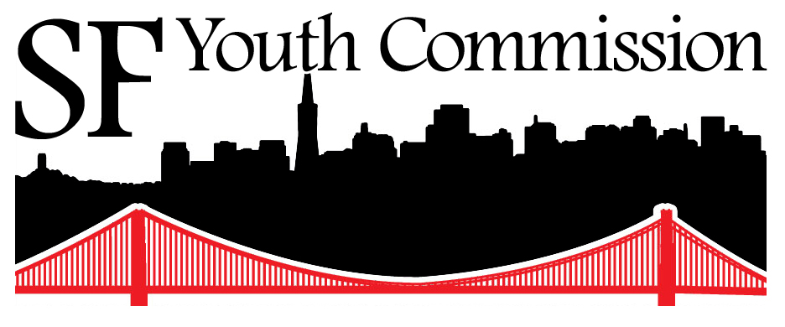
2013-14 Youth Commission Outreach Team DRAFT Work-Plan

