Outreach and Media Plan

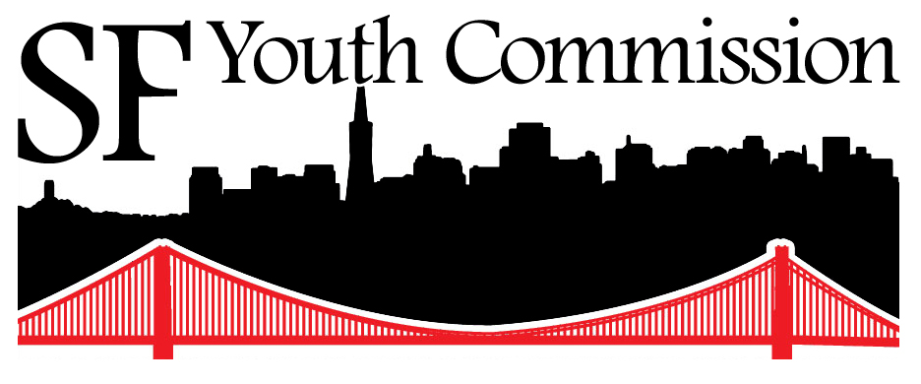

Presented to the Full Youth Commission 12.14.13
DeAsia Landrum | Angel VanStark | Allen Lu (staff)

Our responsibility to youth:
“We are Youth Commission. It is our duty to engage youth and youth-serving allies around priorities that matter to us. With hope, the young people we engage with will be inspired to take a stand for the issues that affect us most. Any relevant information we hear will be brought back the commission to ensure that our policy work is representative of our constituents and that all youth-related concerns are addressed. With great pride, we humbly accept our role as messengers to the Board of Supervisors and the Mayor, and as one voice for the youth of San Francisco”
Goals: The “Why?”
- Educate, encourage, and train local youth to speak up about issues affecting them
- Provide opportunities for youth engagement in local government, decision-making processes
- Create and Increase visibility of YC in the community
- Strengthen relationships with all kinds of organizations and institutions that have youth members or serve youth
- Address the current unmet needs and concerns of young people in our policy work that is relative to the youth of SF
- Make Youth Commission a key site for updates and insight about local youth issues
- Create sustainable infrastructure for outreach for future generations of Youth Commissioners
Branches of YC’s Outreach: The “How”

Outreach related to general YC work
- As we write our resolutions, we invite effected groups for feedback/ideas
- As legislation is referred, we invite those who will be impacted to speak out and encourage them to provide community-inspired solutions.
- We provide a safe and welcoming space for our communities to present relevant items during our meetings
- We regularly meet and update our appointing officials with our policy work
- We will conduct 3 Off-site full YC meetings by July to provide communities easier access to our meetings
- We will come up with community engagement strategies in our committees specific to our issue-based goals
- We will track Youth Commission’s reach in the community through activity logs and social media analytics

Web and Media:
- Newsletter and tracking of community contacts!
- Regular website updates
- A stepped up social media presence with news updates and original content
- Collaboration with youth media outlets
- Youtube Presence and video marketing

Civic Engagement
- Civic engagement and community mobilization curriculum in SFUSD classrooms
- Budget advocacy training sessions for community partners
- City Hall tours

Schools and CBOs: “The Where?”
- Classrooms
- Wellness centers
- School TV stations and newspapers
- Neighborhood forums and district town halls
- Community-Based Organizations (CBOs)

Events: “The Where?”
- Peer Resources “Youth Are Resources” Conference
- The Student Advisory Council Summit
- Bay Area-wide Youth Commission activities/events
- Youth Advocacy Day
- And others!

Our Individual Outreach Goals:
- Committee community engagement strategies and off-site events
- Site visits to at least 2 CBOs in each district: one in the Spring and another in the Winter
- Attend neighborhood forums and district town halls. At least one!
- Keep up with your appointing officer. Please subscribe to their newsletters. (Why?)

What can I do RIGHT NOW?
- Present in a classroom!
- Post on YC social media sites and invite friends!
- Train, prepare, and facilitate a workshop on budget advocacy!
- Outreach in our own schools/communities!
- Help plan summits and events!
- Anything other ideas?

“What kind of support will the outreach team offer?”
- Coordination and scheduling off-site visits and meetings.
- Help preparing and setting goals for site visits and meetings.
- Outreach to community members who can inform your resolutions.
- Support of committee community engagement strategies.
- Support setting goals and keeping track of your work.
- Social media assistance, preparing for site visits, and any other support you need to implement this plan!
- Most of all, accompaniment and moral support!

Communications: Staying updated
- EC updates during committee and full YC meetings
- Outreach opportunity updates to committees
- Weekly internal updates
- Track sheet and activity logs
- Individual check-ins with us!

