

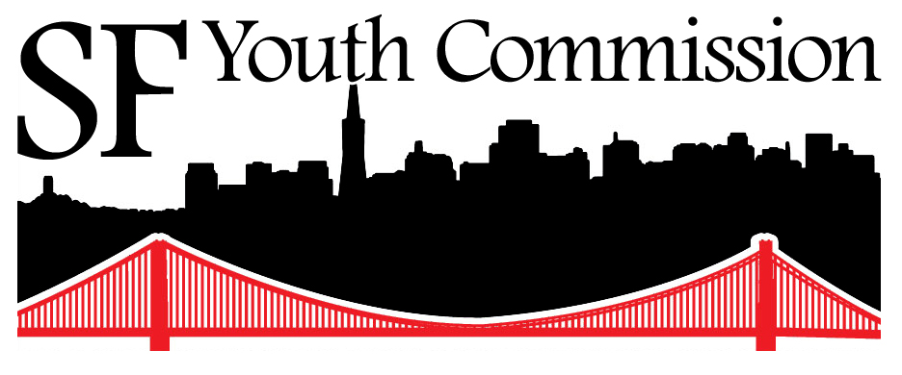

San Francisco Youth Commission

2014-15 Annual Outreach Plan

A Proposal to
Full Commission

Presented on
October 20, 2014

[This is the property of the San Francisco Youth Commission]

Table of Contents

Introduction 3
1 Provide support for committees 3
2 Coordinate 3 or MORE Town Hall Meetings 3
3 Plan 3 or MORE Youth Commission Off-Site Meetings 4
4 Ensure that impacted parties by legislation are present in meetings 4
5 Inform local news organizations about the YC’s work 4
6 Update a generic presentation for Commissioners to present to schools 5
7 Facilitate a short “Youtube bio video” of the Commissioners and Staff 5
8 City Hall Tours 5
9 Be more active in social media 6

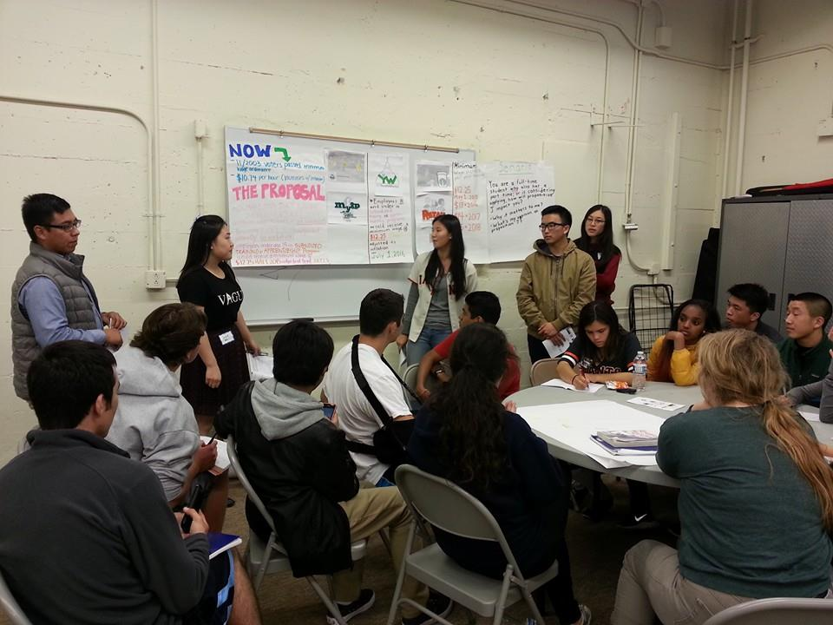
Introduction
The Youth Commission is responsible, under SEC 4.124 of the City Charter, for advising the Board of Supervisors and the Mayor on "the effects of legislative policies, needs, assessments, priorities, programs, and budgets concerning the children and youth of San Francisco." To fulfill this Charter-mandated purpose, we have established in our bylaws (adopted September 9, 2014) to engage in specific activities. This Annual Outreach Plan lays out the goals and methods in which we establish relationships with the young people and adults who work with young people across the city at recreation centers, social service organizations, after school programs, religions institutions, and youth-based organizations.

Provide support for committees
“…we establish relationships with the young people and adults who work with young people across the city at recreation centers, social service organizations, after school programs, religions institutions, and youth-based organizations.”
The pillars of the Youth Commission are its 3 issue based committees: the Youth Justice Committee, the Immigration & Employment Committee, and the Housing, Environment & City Services Committee. This year, we want to ensure that the outreach involved in the priorities and work that come out of the committees are adequately supported. As committees are working on their resolutions and seeking feedback from folks who will be impacted, the outreach team will be there to gather these people, if not share with them the feedback the committees are looking for.
- We will advertise and distribute upcoming events committees are involved in.
- Committees will work closely with the Outreach team, notifying the team of specific support they need.

Coordinate 3 or MORE Town Hall Meetings
Last year, the Commission explored putting on different types of town halls. The first one was a response to the reauthorization of the Children’s Fund, resulting in a town hall where youth evaluated findings from community input sessions, put additional priorities on the board, and individually voted by preference of importance. The second town hall was initiated by the Housing, LGBT & TAY Committee which created a forum where youth were able to share their stories, which provided narratives for the committee’s policy priorities. The last town hall was a District 8 Youth Town Hall where the commissioner worked with their Supervisor to collect information about the needs of youth in that district. This year, we will coordinate 3 additional town halls which will serve as platforms to engage youth and adults who work with youth in our city
- We will invite the organizations, communities, and people who will be affected by the subject matter of the town hall.
- The outreach team will follow up with the committees or individuals on their town hall action planning.

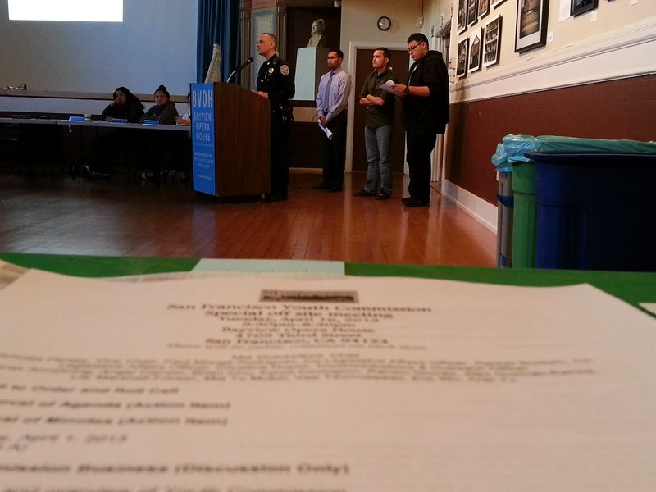
Plan 3 or MORE Youth Commission Off-Site Meetings
The Youth Commission had previously held Full Youth Commission meetings in community spaces to make our work more accessible to the public, and we would like to do this again by holding 3 of our scheduled full commission meetings outside of City Hall this year. We often invite people to our meetings from community based organizations, city departments, school district, and others to our full meetings. If we know ahead of time that we will be receiving a presenter who will be addressing issues specific to the interests of a given community, we will do our best to locate our meeting in that community. That way, our meetings will be more accessible to people who are interested in the items on our agenda.
“…if we know ahead of time that we will be receiving a presenter who will be addressing issues specific to the interests of a given community, we will do our best to locate our meeting in that community.”
- Issue-based committees will inform the Executive Committee their interest in having a Full Youth Commission Meeting in a community space on their specific issue matter a month in advance. The Executive Committee may also request from the Outreach Team support in having an off-site meeting in advance.
- The outreach team will help reserve a community space, invite members of the public, and work with the respective committee(s) in the design/format of the event.

Ensure that impacted parties by legislation are present in meetings
As one of the groups of people who are first in line to hear about legislation coming up from the Board of Supervisors related to San Francisco’s youth community, we need to ensure that those impacted are informed of upcoming meetings where the legislation will be discussed.
- After a respective committee is notified by the Legislation Affairs Officer and/or staff of legislation introduced, they could inform the Outreach Team who the Youth Commission can contact and invite to an upcoming meeting.

Inform local news organizations about the YC’s work
Local news organizations are great portals by which the Youth Commission can share their work around a specific priority. The Commission will be sensitive about which priorities make sense in contacting a local news organization, and understand the objective for the outreach. Do we want to write an opinion editorial? Do we want to reach out to a newspaper staff writer who we think may be interested in the policies we are advocating for and introducing? The Youth Commission can also reach out to other organizations who provides news to the public such as CHALK’s YouthLine.
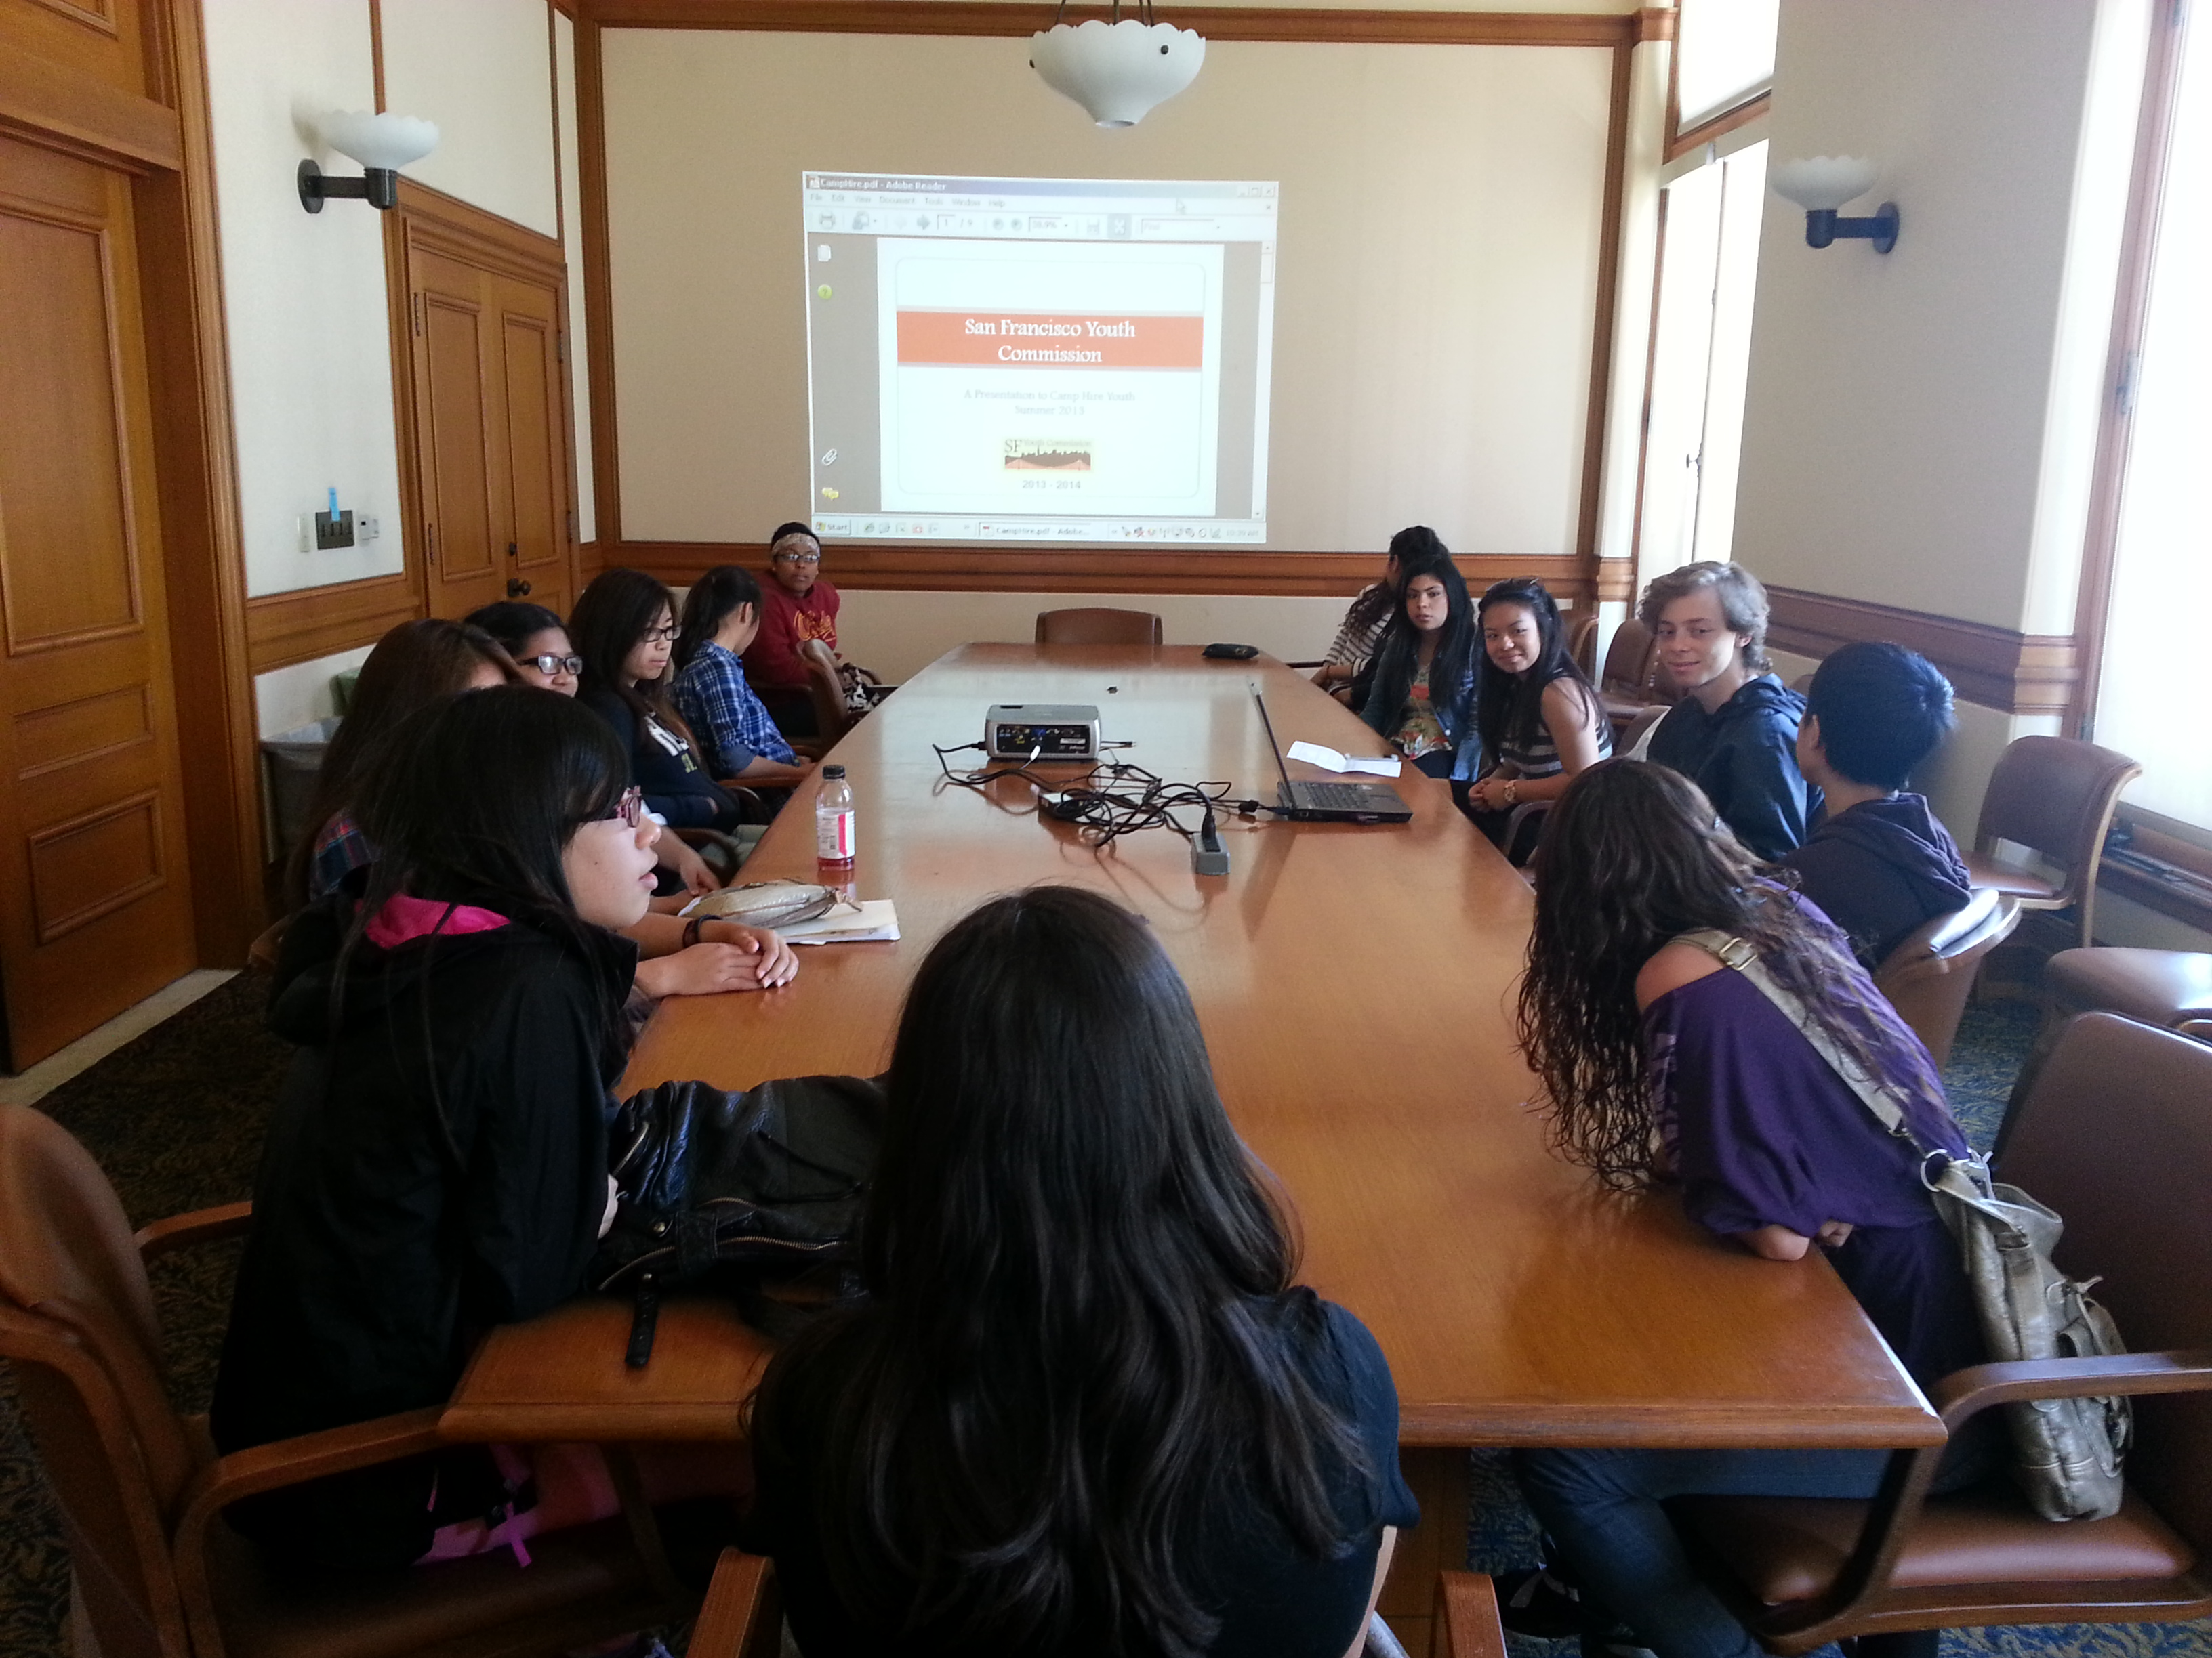
- Committees and/or Commissioners will inform the Outreach team their interest in connecting with a local news organization on a specific issue. The Outreach team will work with them to identify appropriate persons and help initiate contact if requested.

Update a generic presentation for Commissioners to present to schools
Every year, schools and organizations request the Youth Commission to come to their classrooms to give a presentation. Because of this, the Youth Commission has a general YC 101 Powerpoint. It is currently updated to reflect the new commission members, however it may not address any new priorities the Commission is picking up this year. The Outreach team will take the initiative in making any updates and request feedback from the committees throughout the year. This generic presentation will be made public for every commissioner and they may update it as they please.
“…we will be creating a short “Youtube Bio Video” of each Commissioner and staff member.”
- If commissioners learn of a class, school, or organization that is interested in a YC 101 presentation and need support from the Outreach Team, let the team know!
- We may explore other platforms to share our YC 101 such as Prezi, posters, storytelling, etc. Please let the Outreach Team know if you have any ideas!

Facilitate a short “Youtube bio video” of the Commissioners and Staff
To help our constituents put a face to our names, we will be creating a short “Youtube Bio Video” of each Commissioner and staff member. These should be no longer than 3 mintues long and will help others understand who we are on a personal, individual level. These videos will be slowly released on our Newsletter, Facebook, and Twitter. These can also be attached to the bottom of our emails in consideration of the people we are reaching out to.
- At a future check-in meeting with the Executive Committee or staff, you will be asked to come prepared to be video-recorded.

City Hall Tours
We are fortunate to have our Youth Commission Office headquartered within the walls of San Francisco’s City Hall. As such, we should be able to welcome people into our home. We like to demonstrate hospitality to all of our guests and visitors, and even promote the tour whenever we engage people in our communities. In order to do this, we will all become familiar with this building’s history and architecture. This way, we will all be ready to share some interesting facts and stories to the youth who enter our headquarters.
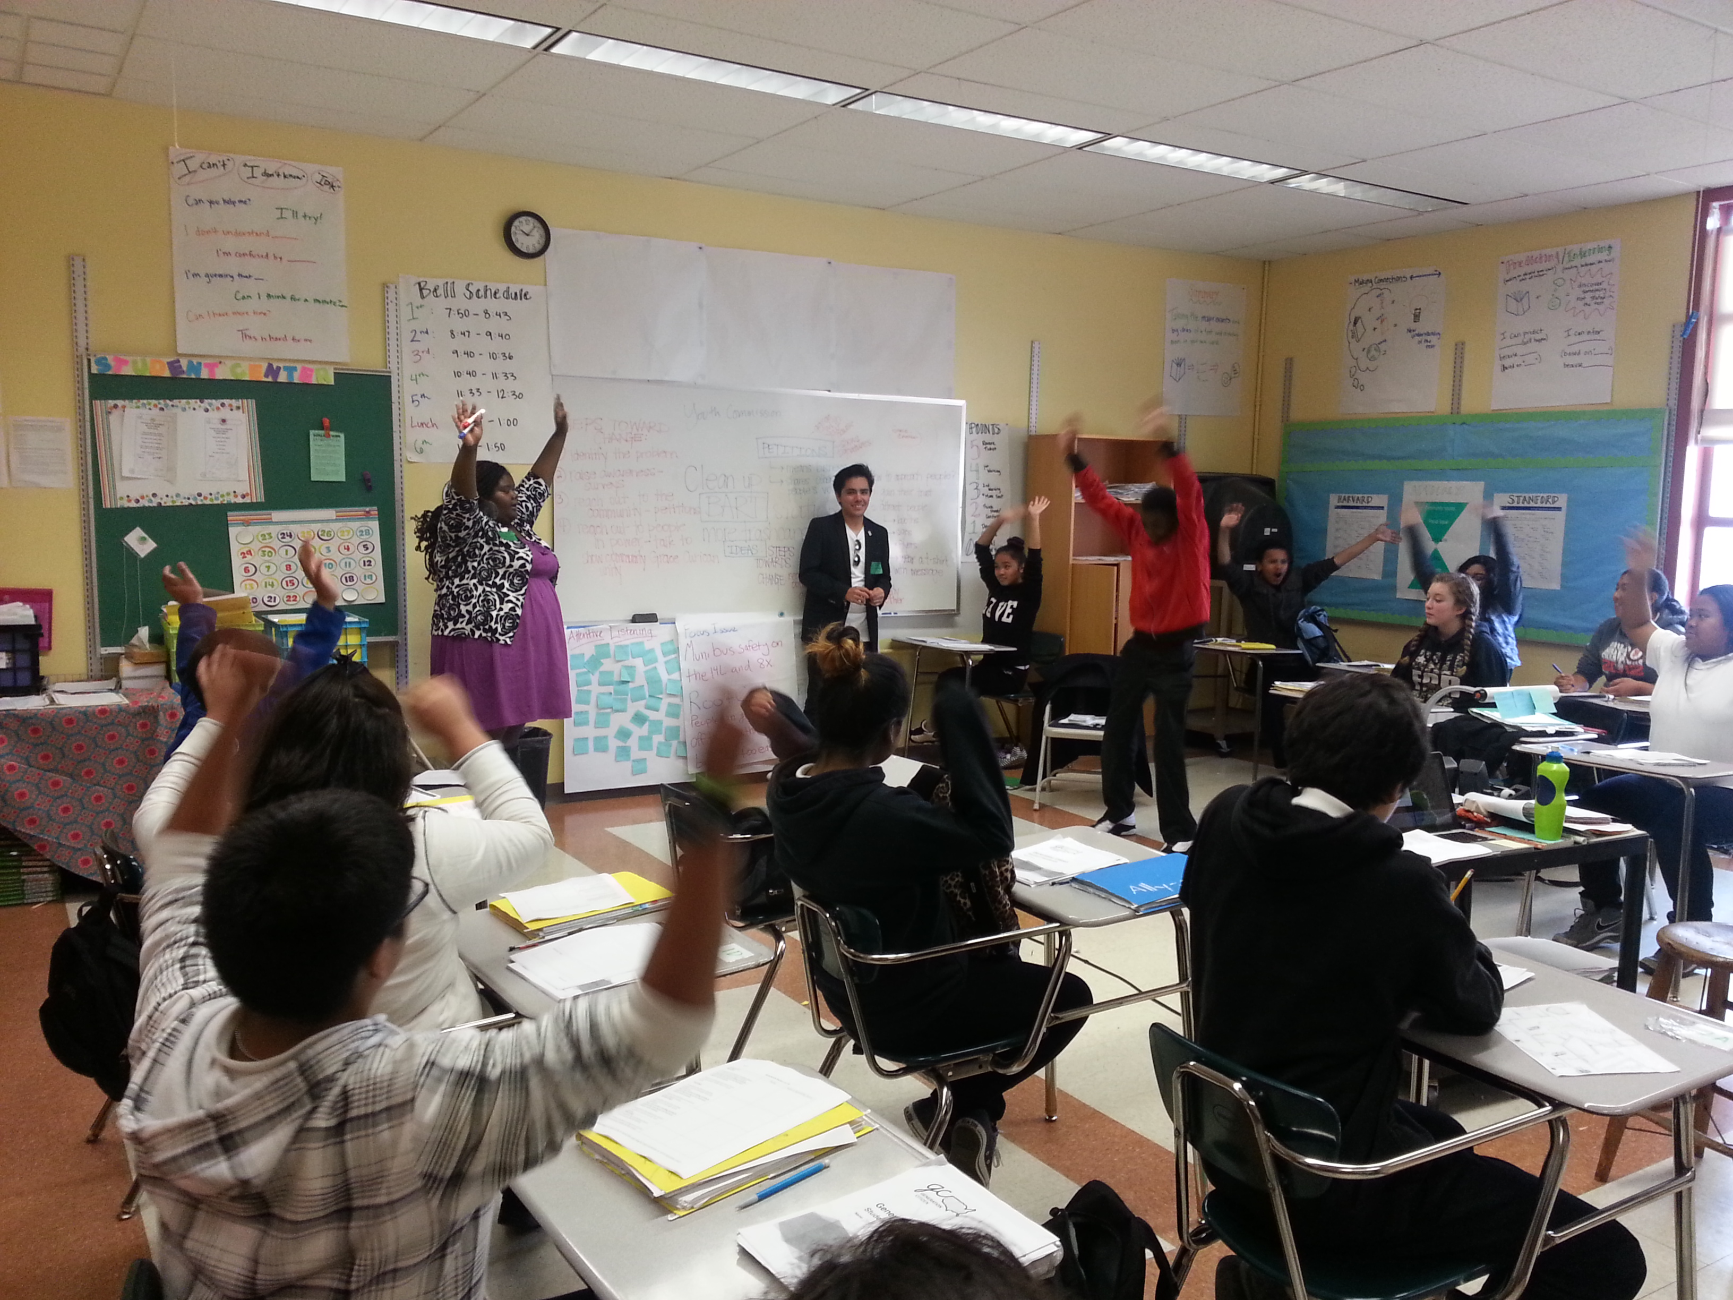
- All commissioners will take a tour by Winter Break with a member of the outreach team, or commissioner who has completed the tour. Commissioners will inform the outreach team once they have completed this.

Be more active in social media
While we already have a Facebook page, Twitter, and Newsletter, we want to branch out to various platforms. Since many young people are immersed in social media, we could utilize it as a tool to allow for better connection with the youth. Social media also offers us a way to advertise important and upcoming events to gain support from others.
- The Outreach Team will create and manage an Instagram account. Follow it when its out!
“…we could utilize it [social media] as a tool to allow for better connection with the youth

